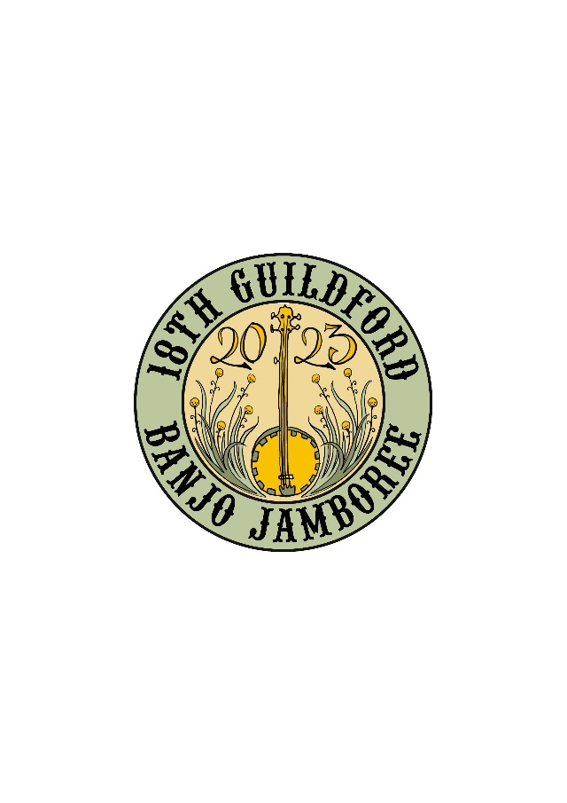

GUILDFORD BANJO JAMBOREE 2023 PROGRAM

FRIDAY EVENING EVENTS: (Ticketed events)
7.30 – 9.30pm: Family Bush Dance – Public Hall
Additional single event tickets may be purchased at the hall.
Featuring a band of talented volunteer musicians and dance callers led by Maggie Duncan.
This is always an event favourite at the Jamboree. Come in and dance your feet off for a couple of hours!
No glass, alcohol or open liquids in the hall – BYO drink bottles – it’s thirsty work!

7.00 – 10.00pm: Chalkboard Session - Music Hall
An adjunct to the Guildford Family Hotel, we will have our Friday night Chalkboard session!
Possums on the Porch will be leading, and all other attendees will be able to put their name on the board and go for it!

SATURDAY MORNING BANJO WORKSHOPS: (Ticketed events)

9.30 – 10.30: Music Hall
Gerry McDonald
The session will be for beginner players, learning how to play a Clawhammer Banjo!
Join Gerry who is a performer with the Duck Down Pickers and learn from a seasoned performer.

9.30 – 10.30: Cricket Pavilion
Brent Davey – Blues and Rhythm Playing on the Banjo
Playing chords and the blues on Banjo: this workshop will explore playing chords on Banjo (Plectrum, Tenor, Uke, 5-string, clawhammer), using the blues and rhythm playing as a framework. Suitable for players from beginner onwards wanting to explore rhythm playing. Brent is well known for his music with the Gut Bucket Jug Band, and this year heads up the Moonlighting Jug Band. He has been playing 4-string ‘standard’ (CGBD) rhythm banjo for longer than he can remember, in jug bands, jazz bands and as a folk musician.

9.30 – 10.30: Stables (at rear of the General Store)
Richard Galluzzi - Playing traditional and non – traditional songs.
Richard coming all the way from NSW will take you through the nuances of playing non-traditional songs. He will take you through how to play in different time signatures, using chords and melody.

10.45 – 11.45: Music Hall
Gus Macmillan – School of Banjo
Gus runs School of Banjo in Brunswick (www.schoolofbanjo.com.au) will be exploring various styles and techniques on the 5-string banjo. This workshop will have something for both beginners and advanced players and be mostly for bluegrass players but with some clawhammer themes as well.

10.45 – 11.45: Stables (at rear of General Store)
Tony O’Rourke - Traditional Irish Music Workshop for Tenor Banjo (GDAE tuning)
In this workshop Tony will be playing and teaching examples of several different tune types: a Jig, Reel, Hornpipe, Slip Jig, Polka, and Slide. An explanation of the different picking methods will be explained as well as some ideas on fretting hand technique. Each attendee will be provided with a booklet of the music covered as well as a CD of the music in the booklet. There will be some time allocated to questions, so have them ready!

10.45 – 11.45: The Cricket Pavilion
Chris Ryan – The Banjo Curiosity Shop Continues
A string instrument enthusiast and one of the founders of the Jamboree, Chris this year will be showing and playing comparisons between various banjo forms and other stringed instruments, as well as demonstrating some frailing and finger-picking techniques on the 5-string banjo. Compare the banjo mandolin and the mandolin, the banjo ukulele and the ukulele, the 6-string banjo and the guitar, the tenor (4-string) banjo and the mandola, the Shamisen (Japanese 3-sringed “banjo”) and the dulcimer. view, try or bring your own.

SATURDAY LUNCHTIME PARADE AND PHOTO SHOOT
From Midday on the oval and thence to the Big Tree. A much-loved Jamboree institution! Coordinated by Marvin Smith and friends, with clowns, a camel, costumes, Banjo Bear, banjos and multiple other instruments. Come and join the fun. The theme tune for this year’s parade will be “You are my Sunshine” – in the key G.

SATURDAY AFTERNOON OLD-TIME JAM SESSION:
MUSIC HALL 1.30 - 3.00pm: (Ticketed event)
A jam session with an old-timey/Appalachian focus, led by Maggie Duncan and friends. All welcome to bring instruments and join in and share tunes or just come and listen.

SATURDAY AFTERNOON BLUES AND JUG BAND SESSION:
MUSIC HALL 3.00 - 5.00pm: (Ticketed event)
A jam session with a blues and jug band flavour led by Brent Davey and members of the Moonlighting Jug Band. All welcome to bring instruments and join in songs and tunes, to contribute songs, or just come and listen.

SATURDAY AFTERNOON CONCERT PERFORMERS:
PUBLIC HALL (Ticketed event)

1.00 – 1.30: OH SUZANNAH
Suzanne Diprose and her band Oh Suzannah, perform Traditional Country in the style of the Carter Family and other early Appalachian artists. With a plain and pure vocal style, she captures the essence of Old-Time music with wonderful simplicity. Playing guitar and singing, Suzanne usually performs in a Trio with string band instruments such as Mandolin, Dobro and Banjo performed by Dave Diprose and Anne-Marie Plevier as well as Andrew Schrape playing mandolin and Brandon Burke on the fiddle.
.

Having studied music of the Appalachians at length Suzanne writes a good deal of her own material and covers traditional and folk songs that highlight women’s issues as well as the struggles of our forefathers and those on the land. She is a regular performer at Mt Pickers and is a finalist this year in the Peninsula Folk Club Song-writing Competition (with winners yet to be announced).

1.40 – 2.10: AWKWARD STRANGERS
Awkward Strangers are a neo-folk duo who have been variously described as ‘theatrical’, ‘witty’, ‘atypical’ and ‘experimental’. Andrew sings and plays banjolele. Anke sings and plays almost anything she can get her hands on, from guitar, clarinet, and flute, to toy piano, kazoo and saw.

They enjoy combining instruments in surprising ways to create and discover new sounds. Sometimes up-beat, sometimes languorous, their songs are thoughtful reflections on the state of the world, intimate explorations of emotions, and cranky rants about political ineptitude.
Discover the awkward stranger within you!

2.20 – 2.50: THE THIEVING MAGPIES TRIO
The Thieving Magpies Trio roam the musical world picking up pretty tunes wherever they find them and occasionally warbling as well. The band comprises local magpies Jane Harding tenor banjo, whistles and vocals, Natasha Mullings flute percussion and vocals, Marnie Sheehan guitar, accordion and vocals. The band is mainly instrumental featuring tunes from the Balkans, Scandinavia, the British Isles and Australia. A couple of originals have crept in as well.
3.00 – 3.30 CHILLI PICKERS
The Chilli Pickers are experienced musicians from Melbourne who play and sing old-time, folk and bluegrass music. Featuring Gus Macmillan on banjo and suitcase, Kate O’Connor on fiddle and Jane McCracken on vocals and guitar. Gus will also be presenting a banjo workshop on the Saturday morning.
3.40 – 4.10: DUCK AND WEAVE
This local band was hewn from a bewitched time when the world went quiet to embrace a tapestry of music blending trad tunes, gospel, and a splash of foot stomping sea shanty into a captivating voyage to distant shore. Featuring immersive sounds of banjo, cello, mandolin and guitars, their instrumental prowess adds depth and character to every performance.

4.20 – 4.50: MYSTERIOUS MOSE
Mysterious Mose scrape, rattle, whine, hoot, honk & holler their infectious brand of good-time, toe tapping jug band music. Expect some classic jug songs, some classic jug band instruments, some unorthodox dress sense, some cheeky patter and lots of fun! Featuring: All on vocals, with Ric Pec on slide guitar & uke, Gaelle Horsley on banjolele, washboard & kazoo, Wendy Dwyer on tenor guitar and saw, Clive Bourne on bass and ukulele, Tony Allan on harmonica, banjo & mandolin.
5.00 – 5.30: DUCKDOWN PICKERS
The Duck Downpickers play acoustic-zyda-Jug-holy-billy-blues, a little tongue in beak! They cite
among their influences Gus Cannon’s Jug Stompers, The Skillet Lickers, R Crumb and The Cheap Suit
Serenaders and the Old Crow Medicine Show. The trio comprises Gerry McDonald – Vocals, 5 String
Banjo and Foot Percussion; Clayton Jacobson – Vocals and Double Bass; and Jonathan Ashley –
Vocals, Acoustic Guitar and Harmonica.

SATURDAY EVENING CONCERT PERFORMERS:
PUBLIC HALL (Ticketed event)

7.00 – 7.10: WELCOME
MC Gaelle Horsely

7.10 – 7.40: DAVID DIPROSE & HILLBILLY RADIO
Multi award winning songwriter Dave Diprose performs original material deeply rooted in bluegrass, folk, blues & the Texas songwriters. Sometimes described as Flatt & Scruggs meets Steve Earle meets the Dingoes, Dave is a performer with decades of experience to boast who has performed with and supported a host of international acts and has appeared at numerous festivals and clubs across the country.
Dave (guitar & vocals) is joined by Hillbilly Radio featuring Mark Pottenger on Mandolin & vocals; Andrew Barcham on bass (both former Nine Mile Creek alumni); and Colin Weight guesting on banjo & vocals. Dave’s song “Stranger In My Home”, about his hometown in North West Tasmania, was recently awarded the Tamworth Songwriters Salute 2022 Bluegrass Song Of The Year.

7.50 – 8.20: DOUBLE DOLE STRINGBAND
The Double Dole Stringband formed in 2020 during the golden era of aggrandized Jobseeker payments. They perform innovative and driving stringband tunes, both original and traditional, reflecting critically upon the old-time tradition. Inspired by personal experience, political discourse, animus for police and love of native birds, the DDSB will have you tapping your toes so hard you'll forget about your misspent taxes.
Based in Naarm (Melbourne) and having performed recently to packed audiences at Dorrigo and Cobargo Folk Festivals, The Double Dole Stringband is comprised of four of the country’s best up and coming old-time players: Grace Bigby, Jimmy James, Jas Bell and National Folk Fellow Luke Byrnes

8.30 – 9.00: BROKEN CREEK
An Old-Time Australiana duo called Broken Creek of banjo and fiddle/vocals that have released a single called 'the Gathering Wool'. They perform original songs about small towns, reimagined folk songs (including traditional Australian bush ballads) and original fiddle/banjo tunes inspired by the landscape.
Lachlan Heycox plays fretless clawhammer and two finger banjo.

9.10 – 9.40: CROSSWIND
“Crosswind”– a 4-piece band, play an energetic variety of music. Whether it’s bluegrass,
folk, classic rock ‘n’ roll or jazz the sets range from quiet acoustic dinner sets to full band
dance brackets, well-paced, and sure to please a wide variety of audiences. Great vocals,
tasty solos, solid rhythms and a lively stage presence are all standard equipment.
Using a range of instruments, they share the vocals and four part harmonies are a feature.

9.50 – 10.20: THE MOONLIGHTING JUG BAND
This lovable combo reinvents the pizzazz of Jugband music from the 20’s Speakeasy era plus originals. Their repertoire covers the 1920s to the jug band revival of the 1960s. Featuring: Brent Davey on banjo and vocals, Teana Amor on washboard and vocals, Barry Martin on harmonicas, tea-chest bass and jug, Marni Sheehan on mandolin, guitar and vocals and Mark Smith on guitar and vocals. Brent will be also presenting a workshop and a jam session.

10.30 – 11.00 MOOSEJAW RIFLE CLUB
Moosejaw Rifle Club is a four-piece folk/country/bluegrass band with four-part harmonies and hooks galore. Their rollicking rhythms have gained attention in every concert venue they’ve played – including our Jamboree audiences. Their original song-smithery melds effortlessly with their more traditional influences appealing to a diverse audience of music lovers. Members: Mick Bourke, Jared Boyle, John Collins, Aaron Robins, Kris Austin.

SATURDAY EVENING MUSIC HALL CHALKBOARD
7.00 - 10.00pm.
Get your name on the list to play to your hearts content.
We have headline acts, MC and the setting for lots of FUN!

SUNDAY FREE EVENTS – No tickets required – all welcome subject to space limitations.

9.45 - 10.45 am: GOSPEL SINGALONG – PUBLIC HALL
Led by the band “Dancing with the Angels” (Bruce Sedawie, Ricki Smit, Tony O’Rourke and friends). All welcome to join the audience for a “clear-the-lungs” gospel singalong. You can obtain a Gospel Songbook on site – bring a gold coin donation. Come along and raise the roof – the acoustics are great!

11.15am – 12.45pm: JOHN (JOHNNO) CALDWELL MEMORIAL JAM SESSION – PUBLIC HALL: The Jamboree Grand Finale.
Jeanette Gillespie, long-time friend of John will MC a fitting memorial to Johnno with performers honouring him with a few of his songs and the tunes he loved and will welcome everyone for a Jam session to close off the official 2023 Guildford Banjo Jamboree! One of the chief founders of the Jamboree, Johnno left New Zealand to make Australia his home in the early 1970’s, and eventually found his way to Guildford. He was a talented player of the guitar and fiddle and a prolific song-writer, and played in numerous bands over many years. His greatest love was the Old-Timey style of music, but he also loved classical guitar, and Irish and Bush Dance music. Come along and reminisce and celebrate with us.

2.00 – 5.00pm: BANJO OPEN MIC – Maurocco Bar, Castlemaine
As an adjunct and extension to the Jamboree, John Hannah has arranged for the monthly Open Mic at the Maurocco Bar (in the Midland Hotel building opposite the Castlemaine railway station, 4 Templeton Street) to be a partly banjo-themed afternoon. If you wish to play, turn up at the door asap after 1pm to register for a 15 minute or 3-song spot. Nine spots available. First in first served! All welcome to come and watch - $5 entry for audience members.

